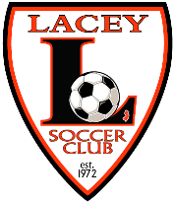
Lacey Soccer Club
www.laceysoccer.com

PO Box 946, Forked River, NJ 08731

Lacey Soccer Club
Sponsorship Sign Agreement

Agreement Between

Lacey Soccer Club

And

___________________________________________________________
Please print exactly how you would like the name of your business to be printed on your sign. You may also attach a business card with a high resolution JPG photo of your logo.

___________________________________________________________
Phone Number

This Agreement is to certify that ______________________________ has agreed to become a Sponsor of the Lacey Soccer Club. The term of this agreement shall be for a period of the Spring and Fall season ( April-November of the current year) with the option to renew annually approximately one month prior to the beginning of the new season.

As part of this agreement ___________________________________will make a donation in the amount of $275.00 payable to the Lacey Soccer Club. In return, Lacey Soccer Club will agree to use said sponsors name on signs displayed at Hebrew Park fields as well as promote their services on the Club’s website, www.laceysoccer.com. Said sponsor will have the opportunity to renew this agreement annually for a donation of $175.00 Payable to the Lacey Soccer Club.

_________________________________ _______________________________
Sponsor representative (print) Lacey Soccer Club representative

_________________________________ _______________________________
Signature Signature

_________________________________ ________________________________
Date Date

